PATIENT
NAME: DATE:
DETAILS:

DATE OF BIRTH: WORKERS COMPENSATION

REFERRER DETAILS: PROVIDER NUMBER:

COPIES TO:

SIGNATURE___________________________________________ DATE:
YOUR DEDICATED ULTRASOUND SERVICE
Imaging Request
NEW SOUTH WALES
New England Imaging Trust
ABN 39 831 188 984
Ultrasound Use
Patient ID O
Procedure & consent O
Are you returning to your doctor today? O

Obstetric ultrasound:
G P
Date LMP:

Your doctor has recommended that you use Armidale Ultrasound. You may use another provider but please discuss this with your doctor first.
ARMIDALE NSW
210b Rusden street
PH: 02 5795 1155
FAX: +61 2 6711 1135

Results
O Secure Download
O FAX
O CD

CLINICAL NOTES
REFERRING DOCTOR
EXAM
Easy
Safe
Affordable

We are located at 210b Rusden street, between the New England
Veterinary Clinic and Move Better Physiotherapy and across the
road from Rusden street Medical Centre.
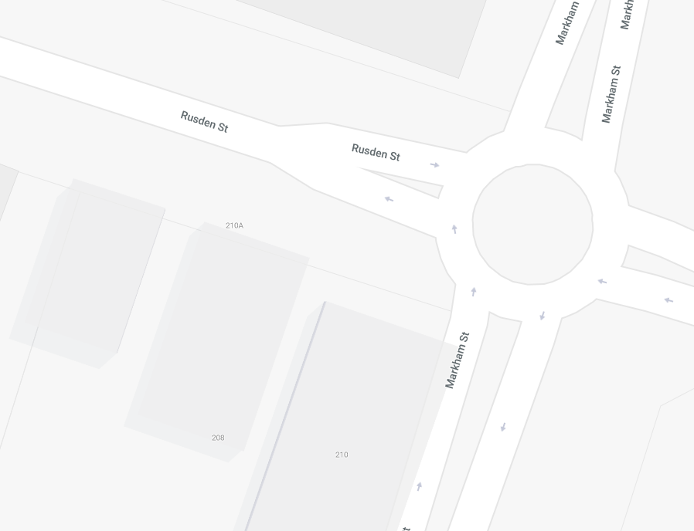
Rusden Street Medical Centre

What Ultrasounds do we do?
- ALL General Ultrasounds
- ALL Vascular Ultrasounds including:
Leg arteries with ABI measurements
Renal arteries
Chronic venous insufficiency or Varicose Vein scans
We do not offer Venous mapping
- Paediatric Ultrasounds including:
Paediatric spine and Hips
Pyloric stenosis
- Perineal ultrasounds to determine the cause of Incontinence
- All Obstetric Ultrasounds including but not limited to
Nuchal scans with the risk of developing Pre-eclampsia calculation
3D / 4D Ultrasounds available
- Mobile service of General Ultrasounds for bed-ridden patients and patients in Aged-care facilities

All expectant mothers who have their Dating / Nuchal and/or Morphology scans with us will receive a free 15-minute 3D/4D theatre experience.
New England Imaging Trust
ABN 39 831 188 984

